**7.1.3 - Describe the facilities in the Institution for the management of the following types of degradable and non-degradable waste (within 200 words)**

• Solid waste management

• Liquid waste management

• Biomedical waste management

• E-waste management

•  Waste recycling system

• Hazardous chemicals and radioactive waste management.

**Solid Waste Management:-** College has a place on its campus where the solid waste materials are disposed of the collecting, treating and disposing of solid material that is discarded because it has served its purpose or is no longer useful. Solid waste management is extremely important in the college mainly because it will **prevent college premises from experiencing the hazardous outcomes of solid waste material.** By getting rid of most of this waste matter properly, you can actually protect students and staff along with the environment.

**Liquid Waste Management:-** The wastewater is carried out through the pipeline. The system collects the water and releases it to the plants to survive in the summer season.

**Biomedical Waste Management:-** There is no biomedical waste management system in the college.

**E-waste Management:-** There is no e-waste management system in the college.

**Waste recycling system:-** There is no system for Waste recycling in the college. However, there is a rainwater harvesting system in the college.

**The e-medical Waste Management:-** There is no e-medical waste management system in the college.

**Hazardous chemicals and radioactive waste management:-** There is no Hazardous chemicals and radioactive waste management system in the college.

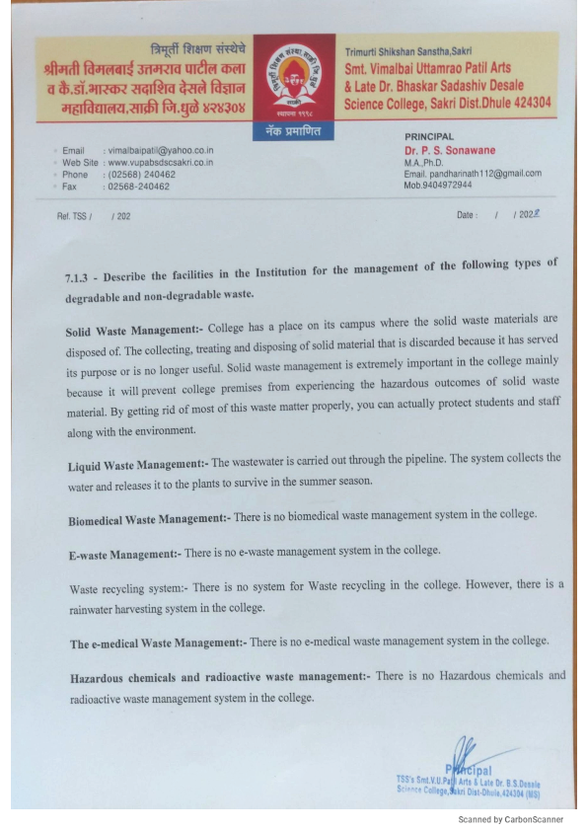

**• Solid waste management.**

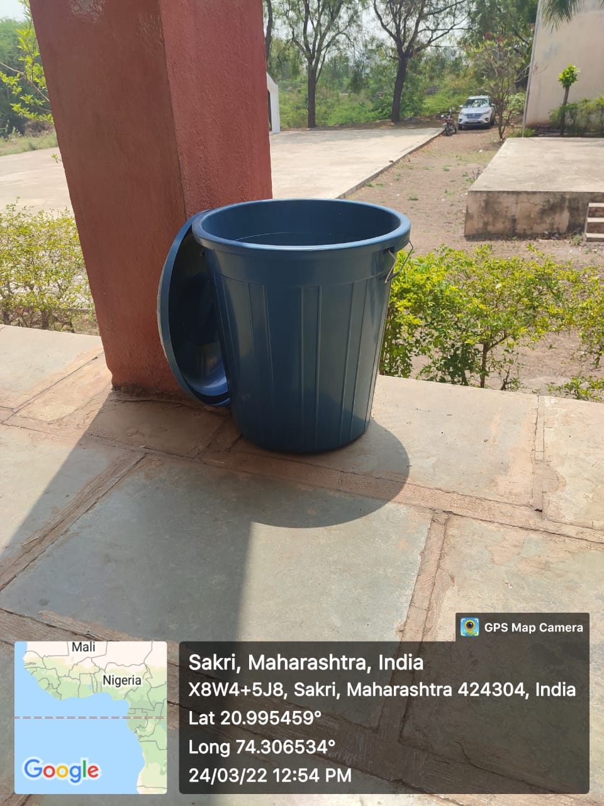

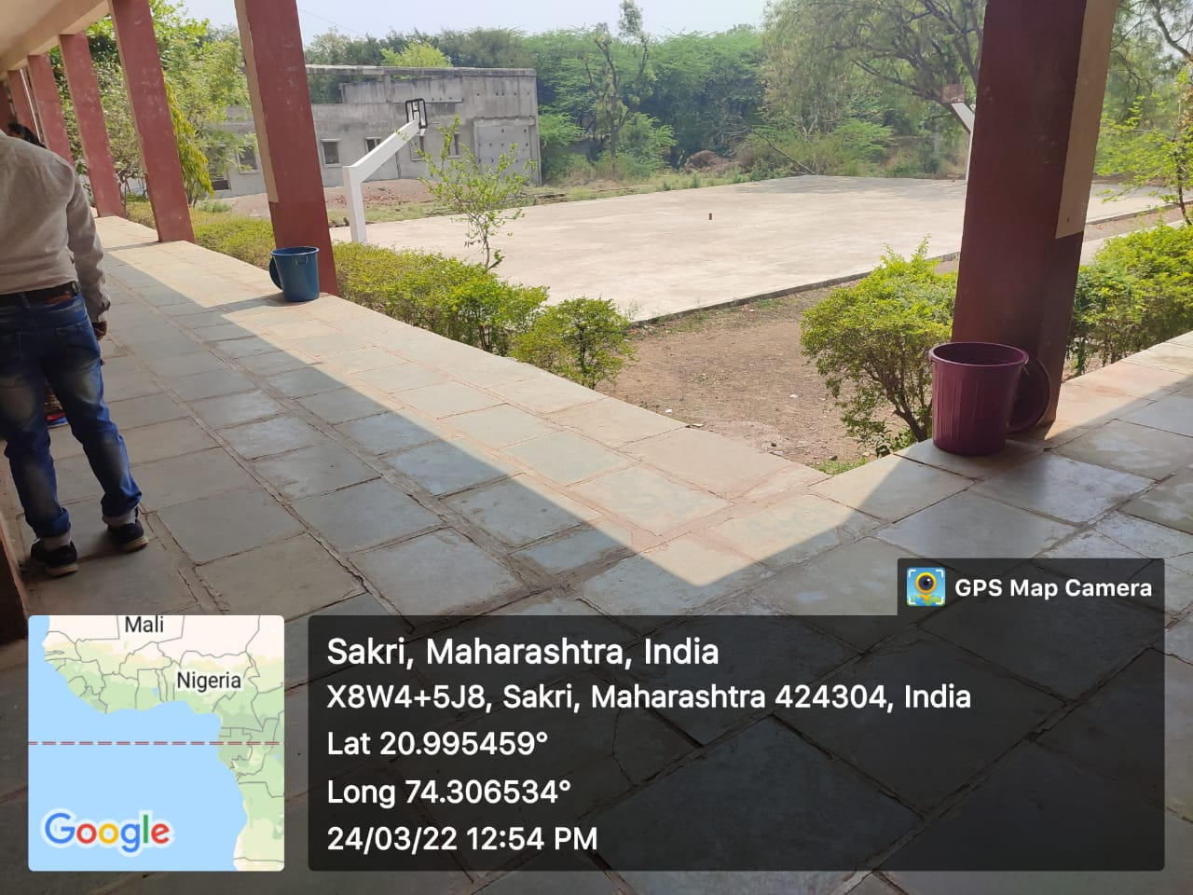

**• Liquid waste management:-**

