**7.1.4 - Water conservation facilities available in the Institution:**

1. **Rain water harvesting**
2. **Bore well /Open well recharge**
3. **Construction of tanks and bunds**
4. **Waste water recycling**
5. **Maintenance of water bodies and distribution system in the campus**

**Rain water harvesting: - (Work in Progress)**

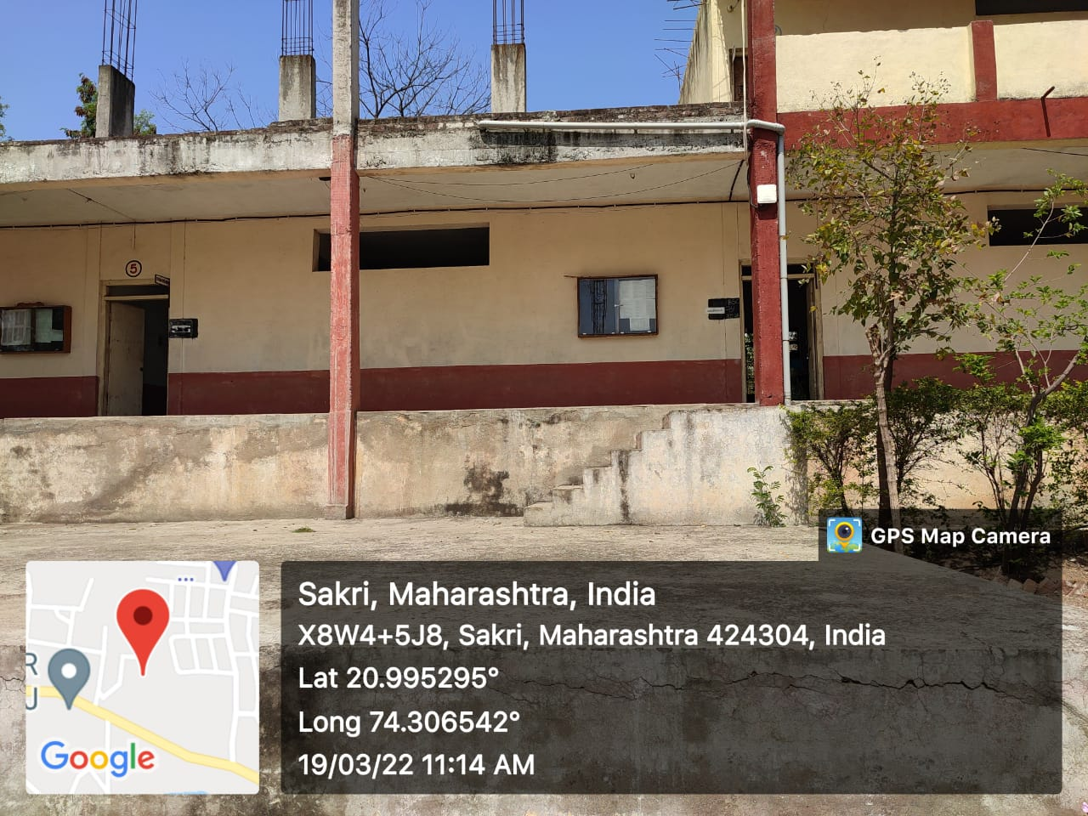

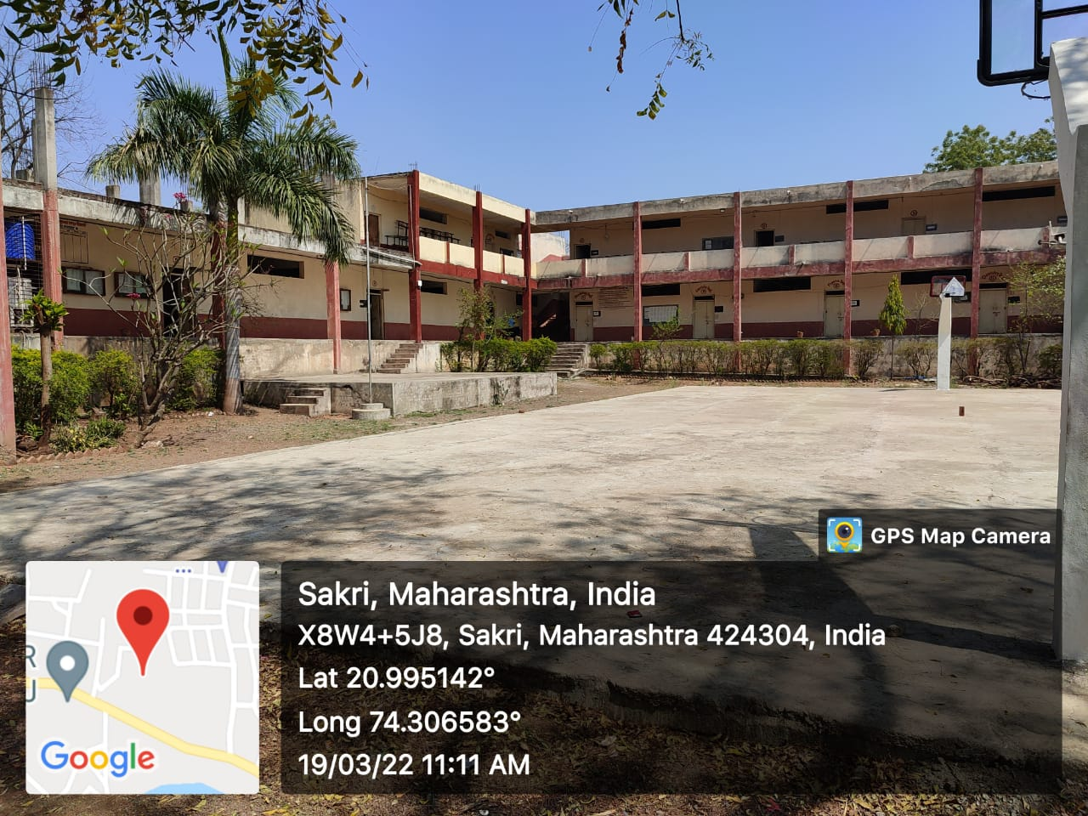

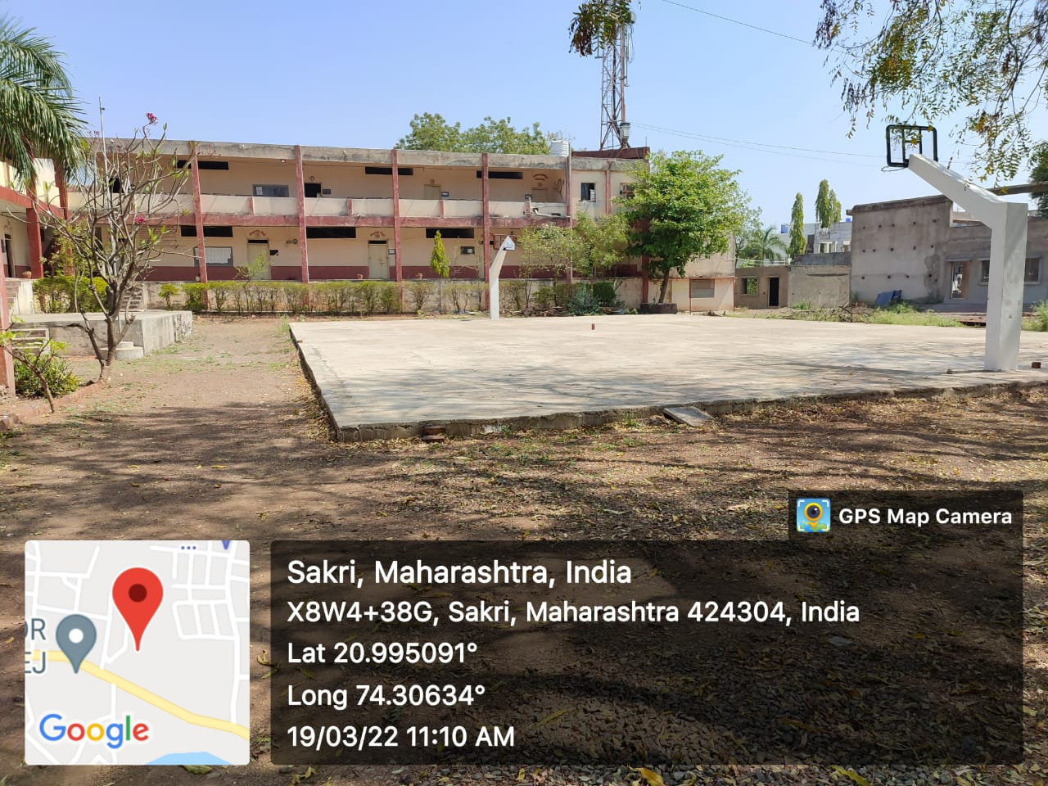

**Bore well /Open well recharge:-**

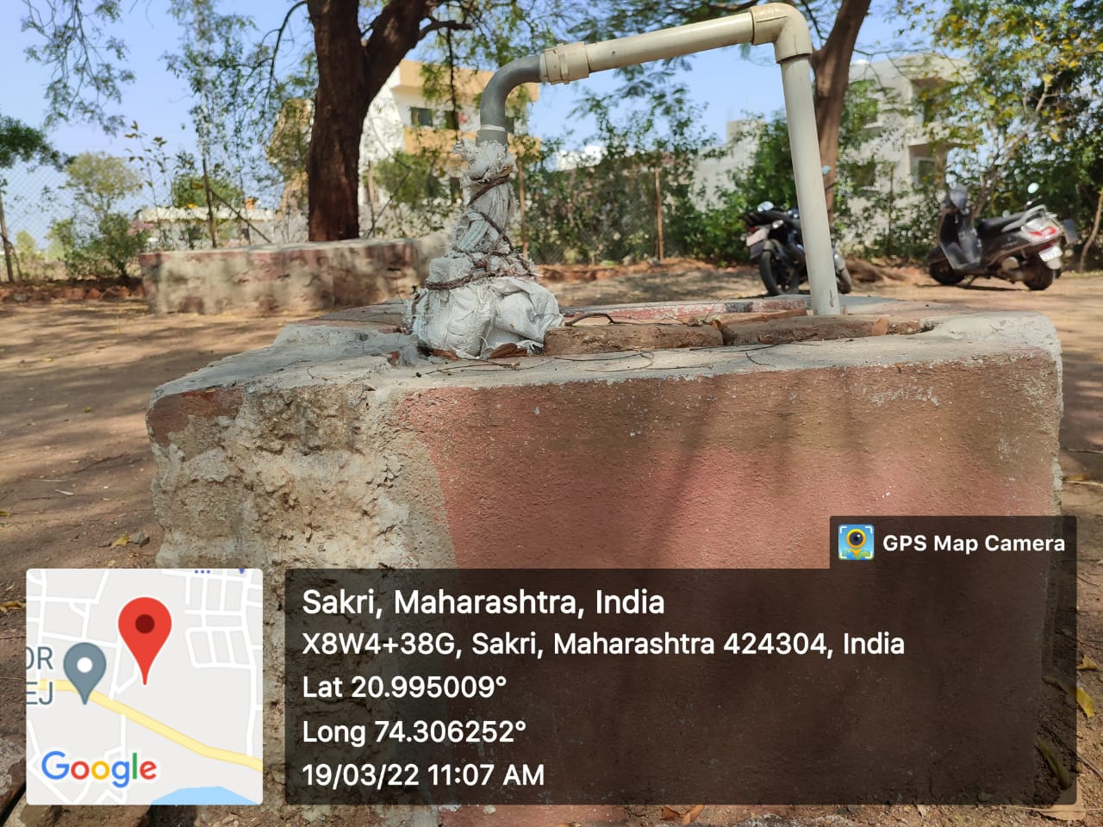

**Waste water recycling:-**

