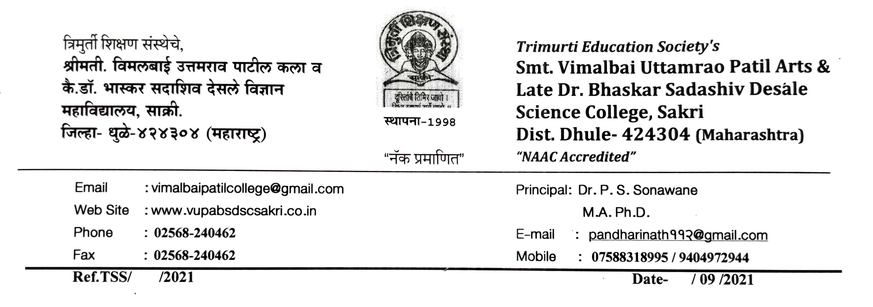

**7.1.7 - The Institution has disabled-friendly, barrier free environment**

1. **Built environment with ramps/lifts for easy access to classrooms.**
2. **Disabled-friendly washrooms**
3. **Signage including tactile path, lights, display boards and signposts**
4. **Assistive technology and facilities for persons with disabilities (Divyangjan) accessible website, screen-reading software, mechanized equipment**
5. **Provision for enquiry and information: Human assistance, reader, scribe, soft copies of reading material, screen reading.**
6. **Built environment with ramps/lifts for easy access to classrooms.** 